- Show the charter trip number, date, and destination.
SELECT char_trip, char_date, char_destination from charter;
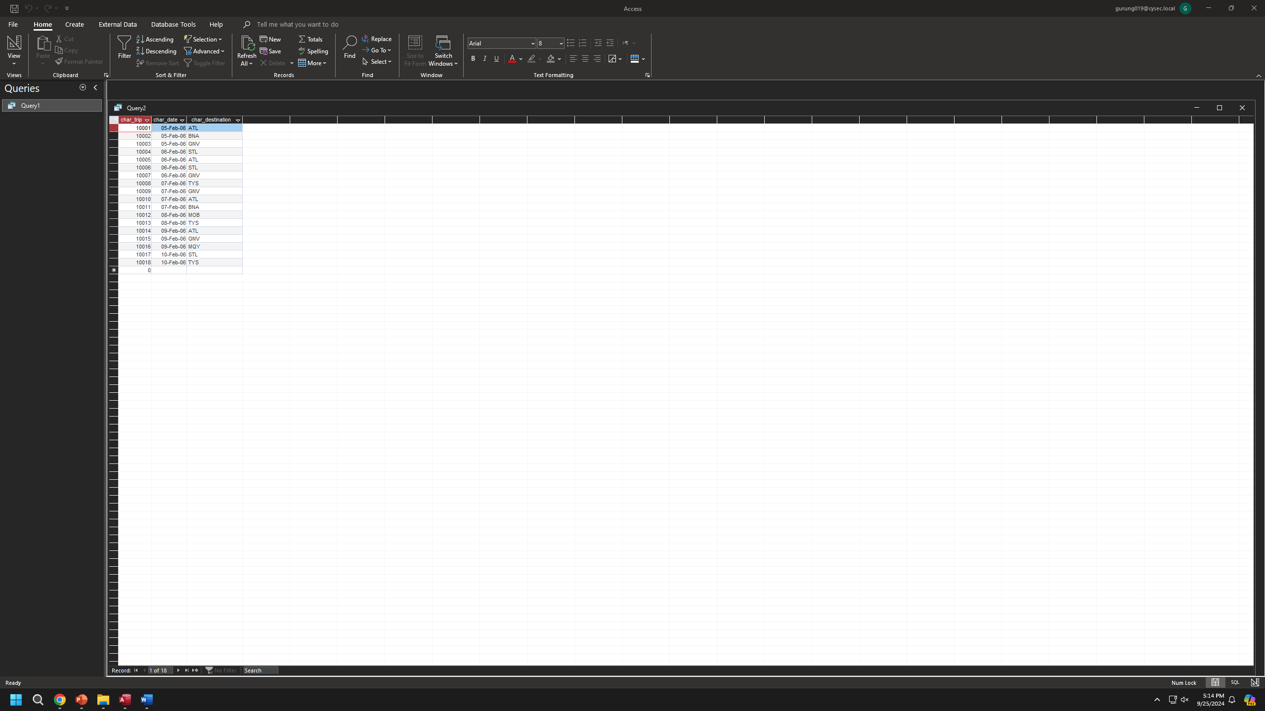
- Which charters are using the aircraft 2778V?
SELECT char_trip from charter where AC_NUMBER = "2778V";


- What are the average hours flown by aircraft going to “ATL” – Atlanta?
SELECT avg(CHAR_HOURS_FLOWN) AS
AVG_HOURS_FLOWN FROM CHARTER
WHERE CHAR_DESTINATION="ATL";

- How many flights are going to each city?
SELECT
- Which customers who went to ATL did not go to STL?
- Which customers who went to ATL did go to STL?
- Did any customers with an outstanding balance charter a flight on Feb. 5 or Feb. 6?

